Boiling Ice Lab
NAME: _ Score: ____________
PARTNER:_______________________

PRE-LAB
1) Draw a particle diagram for each state of matter: solid, liquid, and gas.
solid | liquid | gas

2) Why do we draw the solid particles stuck together?

3) In this experiment you will be measuring the temperature of water as it changes phase from solid to liquid to gas. Predict what the temperature versus time graph will look like.
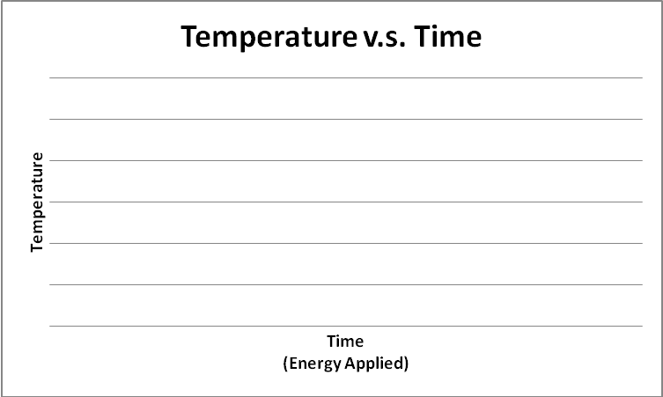

PROCEDURE (Put an X by each step after you complete it!)
____0. Put on your goggles, and check that every group member is wearing goggles.

____1. Send one group member to the front to get a beaker with ice and thermometer.

____2. Place the beaker on the hot plate (turned off), stir for 15 seconds, then record the initial temperature.

____3. Plug in the hot plate. Turn it on to maximum. Stir constantly and record the temperature every 30 seconds.

____4. Make special note of the exact time and temperature when all of the ice has melted. This is an important point on your graph.

____5. Make special note of the exact time and temperature when all of the water is boiling. This is an important point on your graph.

____6. Continue recording the temperature until the water has been completely boiling for 5 minutes.
____7. Unplug the hot plate and allow the beaker and water to cool. Then pour the contents down the drain. Be careful not to burn yourself! While you are waiting, begin to graph the points on the data table. Then return all supplies to where you got them.

DATA TABLE

Time | Temp.(°C) | Time | Temp.(°C) | Time | Temp.(°C) | Time | Temp.(°C) | Time | Temp.(°C)
0:00 |  | 5:00 |  | 10:00 |  | 15:00 |  | 20:00
0:30 |  | 5:30 |  | 10:30 |  | 15:30 |  | 20:30
1:00 |  | 6:00 |  | 11:00 |  | 16:00 |  | 21:00
1:30 |  | 6:30 |  | 11:30 |  | 16:30 |  | 21:30
2:00 |  | 7:00 |  | 12:00 |  | 17:00 |  | 22:00
2:30 |  | 7:30 |  | 12:30 |  | 17:30 |  | 22:30
3:00 |  | 8:00 |  | 13:00 |  | 18:00 |  | 23:00
3:30 |  | 8:30 |  | 13:30 |  | 18:30 |  | 23:30
4:00 |  | 9:00 |  | 14:00 |  | 19:00 |  | 24:00
4:30 |  | 9:30 |  | 14:30 |  | 19:30 |  | 24:30
Continue on a separate page as needed.

ANALYSIS (Complete this part independently).

____1. Graph a time vs. temperature graph on a separate sheet of paper. Show the solid, liquid and gas phases.

____2. Divide your heating curve into three regions; label each region: (A) a low temperature plateau (B) a region of temperature change (C) a high temperature plateau

____3. Answer the following questions.
- Did the system in this lab involve a chemical change? Explain.

- Did the system absorb or release energy? Was this an exothermic or endothermic process? Explain.

- How would increasing the rate of heating change the shape of the curve?

- For Region A low temperature plateau:
a. state what phases of matter were present

b. draw a particle diagram that shows how the water molecules were behaving.

- For Region B low temperature plateau:
a. state what phases of matter were present

b. draw a particle diagram that shows how the water molecules were behaving.

- For Region C low temperature plateau:
a. state what phases of matter were present

b. draw a particle diagram that shows how the water molecules were behaving.

Grading Rubric
Pre-Lab | Are the pre-lab questions completed & correct? | /2
Procedure | Were all steps completed? | /1
Data | Is the data table completed? | /1
Graph | Is the graph attached?  Does the graph include titles, labeled axes, and proper scaling?  Is a smooth curve connecting the points of the graph?  Is the graph labeled with states and regions? (Analysis 1-2) | /5
Analysis | Are the other analysis questions completed & correct? | /6

